**PROJECT REPORT**

**TOPIC: IMMIGRATION TO CANADA**

**PERIOD – 2000 TO 2013**

**JANHVI VORA**

**300323626**

**SUBMITTED TO –**

**PROF. BAMBANG SARIF**

**DATE – 27TH JULY, 2020.**

**INTRODUCTION:**

* The Visualization tool that I have used for this project is **Tableau.**

I Like working with Tableau because of its creative and responsive features.

It can handle large datasets and the Data interpreter is also very helpful for Data Cleaning.

The Analytic functions are also easy to use. Even people with less experience in Data and Coding techniques can use Tableau effectively and efficiently.

One of the most attractive features for me is the geospatial maps. I love visualizing data on maps and tableau helps me do it very accurately.

* The Dataset that I chose was **Immigration to Canada**.

I have always been interested in the Citizens of the World. Because of which, I am very curious about who is moving where and why. Now since I, myself am an immigrant in Canada, I thought it would be interesting if I work on Immigrants coming to Canada from all over the world.

There are a lot of International exposure for us. Earlier going out of our Country was a very big deal and not so common. People are now moving for better lifestyle to different places in the world. Canada is one of the countries with highest number of Immigrants. I would like to see the places from where people want to come to Canada.

**STORY:**

QUESTIONS:

1. Which Region is migrating the most to Canada?
2. People migrating to Canada are from developing or developed countries?
3. Which province of Canada do people prefer to move to?
4. Which countries contribute most to the immigrant population in Canada?
5. What are the changes in migration over the period?
6. Country wise analysis of migration, is it dipping or increasing?

* As it is known, Canada is a country of immigrants. One Quarter of Canadian population in made of immigrants. Different people from different countries bring different races, ethnicity, habits, and values with them. With a large population with unknown origin, it must be difficult to control and anticipate their actions.
* To build a happy, co-ordinated, and healthy country, we should understand people and their needs. When we know people and their cultural backgrounds, we can not only anticipate their actions but also provide them with their form of happiness.
* For example, Indians love food and dance, Chinese prioritize Health over everything, British people love tea and the people of Morocco love color and slow-paced lives. To provide all these things to the residents of Canada, we need to know the major chunk of our population. Hence, this visualization will provide us with good insights about the immigrant population of Canada.

INTERACTIONS WITH THE VISUALIZATION AND INSIGHTS:

* With a map of Canadian provinces, we visualize where do most immigrants prefer to move and settle.

Color density depicts no of immigrants.

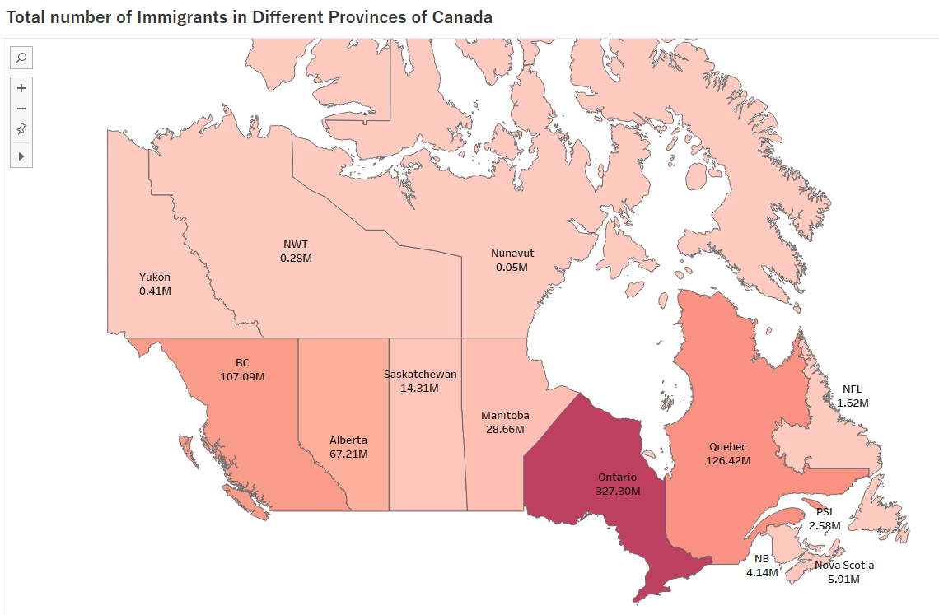

**We can conclude most immigrants prefer Ontario, British Columbia, and Quebec.**

**With further research we can find that Ontario has maximum career opportunities, BC has favourable climatic conditions and if you speak French, Quebec is where you’ll want to be.**

**If you select any part of the map, you can explore some amazing cities to live in Canada.**

* With a circle chart, we visualize which countries contribute the most from throughout the world.

Size depicts no of immigrants and color depicts the region.

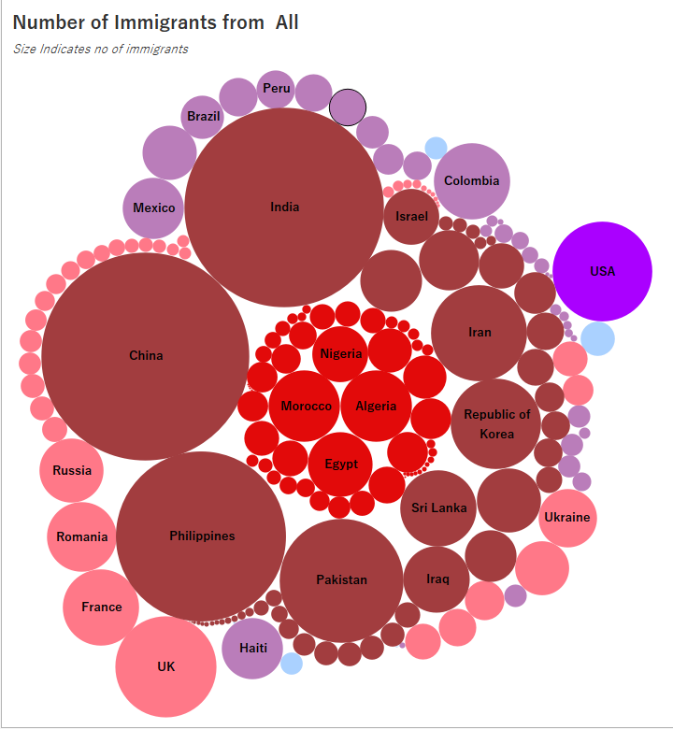 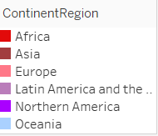

**We can see India, China and Philippines are contributing the most and they belong to Asia.**

* We can choose any Region to filter the visualizations and get detailed information about that region.

Example if I choose Europe:

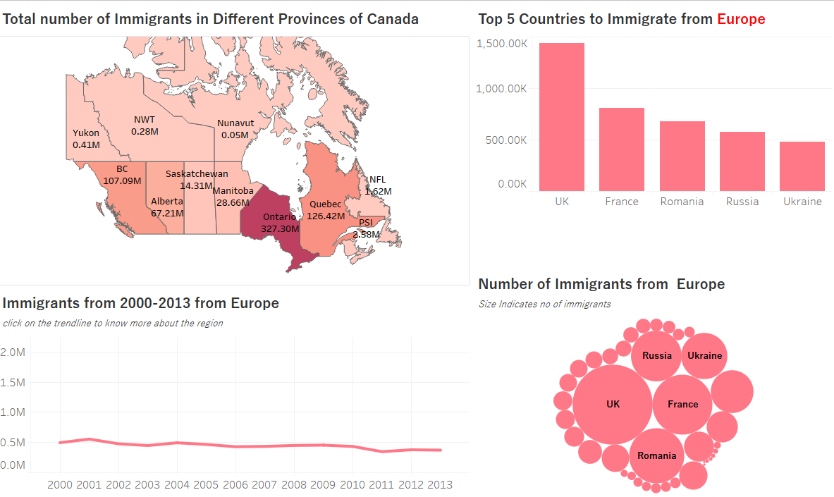

**The visualization changes this way showing top 5 countries contributing from that region, and the timeline to highlight region’s trendline, tooltips also give us information about the countries being developing or developed nations. To check reasons why developing countrymen are moving to developed nations or vice versa, there is an informative link when you select the nation category.**

* Timeline shows overall region-wise Immigration to Canada.

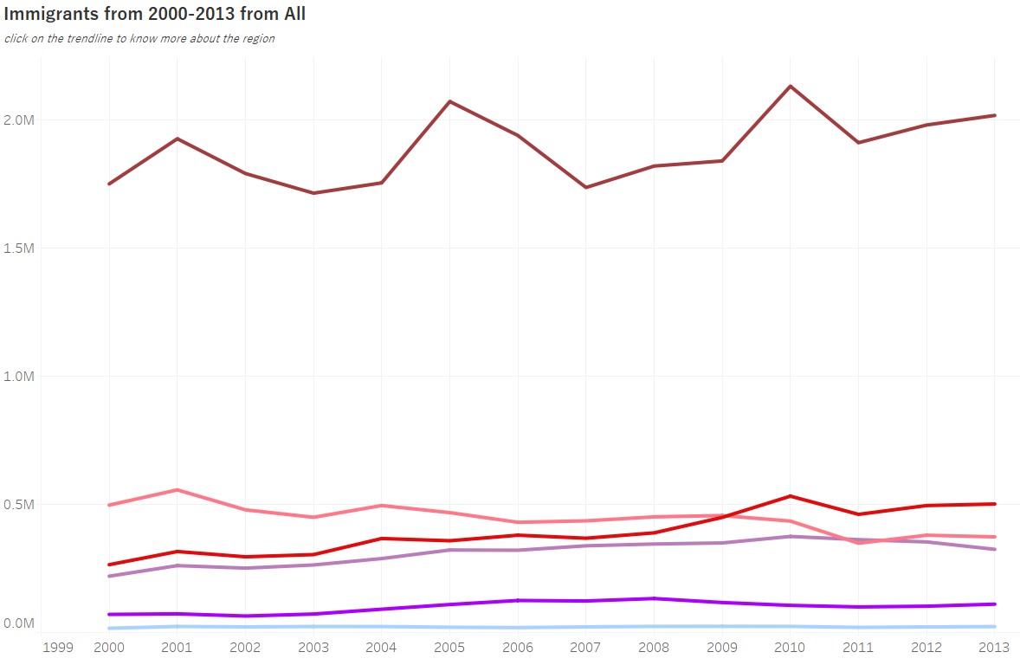

**We can easily conclude, people from Asian Countries immigrate far more than any other region.**

**This tells us that the need to immigrate is much more in Asian countries than any other region.**

**With further research, we come to know the main issue in Asian countries is Population and Pollution.**

**Population kills individual opportunities and pollution and climate change make it difficult to enjoy the environment.**

By Clicking on any timeline for a region, we can see the map of the region and statistics of all the countries included in it. The color density depicts no of immigrants.

Example, When I select Africa:

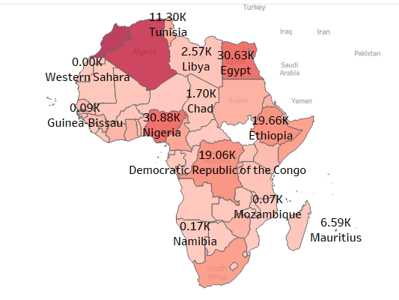

We can check the changes over time for a Country by selecting any country from the above map. It shows the timeline and the forecast till 2019 with 90% confidence interval.

**With further research, the forecasting has almost matched the current value of immigrants. Although a lot of data is not available for the last 2 3 years.**

Example when I select Nigeria:

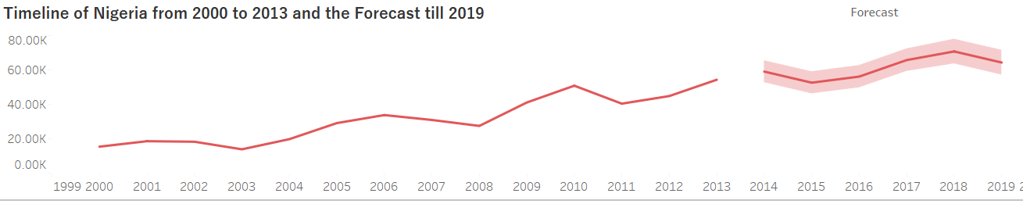

* There is also one table that tabulates the countries that have had a very changed impact on the total no of immigrants in the span of 13 years in a region.

Table for Europe:

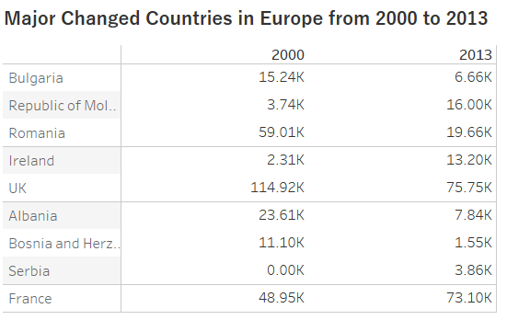

**We can see people migrating from Romania, UK and Albania have decreased over the years. The reason being their life is improving in their respective countries or they are moving someplace else. We need to do further analysis to be sure. Whereas people from France are migrating more than before.**

**CONCLUSION:**

* By getting to know the pattern of migration for regions and different countries, we can be certain about the origin of immigrants for coming years.
* With these insights, people can choose where to migrate depending upon their priorities. They can also find where most people similar to them are settling.
* Canada is a developed country. As the 11th-largest world economy, Canada has a diverse economic base.

A lot of immigrants come here from developing countries to find good education, career opportunities, comfortable climate, and a better lifestyle.

* Since most of the population comes from India, China, and Philippines, it will be good to accommodate some platforms for their recreation which might make their life more content while miles away from the origin country and family.
* Immigration to Canada is gradually increasing, but its not a steep incline. Immigration is in control.

PRESENTATION LINK: